**Health & Safety Talk**

**Housekeeping**

Poor housekeeping is often an unreported cause of workplace injuries in the automotive industry. Hoses, leads and cords strung out across the floor, obstructed walkways, and spills not cleaned up immediately can all result in serious injury.

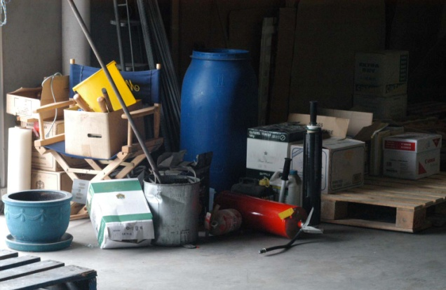

**What are the risks?**

* Slips, trips and falls
* Long term injuries
* Cluttered work areas resulting in dangerous practices

**What should be done?**

* Staff should be advised to clean up as they go (e.g. don’t leave unused leads lying around).
* Throw out any un-used items and replace tools and equipment to a designated position.
* Make use of the spill kit where necessary and clean up spills immediately.
* Keep walkways / areas always clear of obstruction.
* Put aside 15 minutes at the end of each day to do a quick clean up of the workshop area.

**Who is responsible?**

Everyone is responsible for housekeeping. Constant everyday up-keep of the cleanliness of the building is required by all.

|  |  |
| --- | --- |
| **Consultation** |  |

**Date of Meeting:**_____________________

**Attendees** (list attendees present)

|  |
| --- |
|  |

**Items Discussed**

|  |
| --- |
|  |

**Action Items**

|  |
| --- |
|  |

**Management Sign Off**

**Name:** _______________________________________

**Sign:** ___________________________________ **Date:** ______________________________